How to make a Spiral Staircase

In this project you will be using Array allot. This is a very useful function. Some is to scale, others I make up as I go along. The purpose here is to give you an idea of the mechanics and then you can do your own designs.
First to make is a step, create a Circle as shown. 4 unit rad.
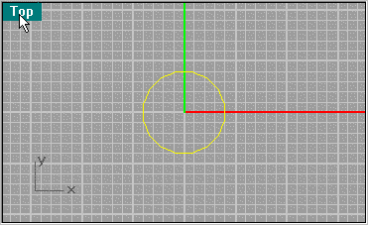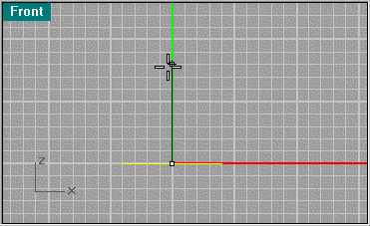
Next create a Curve/Helix, same radius and 8 units high, and one turn.
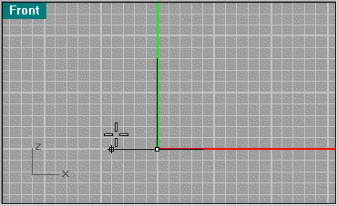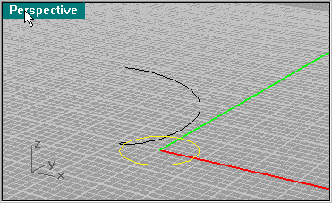
Next use Surface from Planar Curves to create a surface from the circle. Next create a Line Segment from the center to the side.
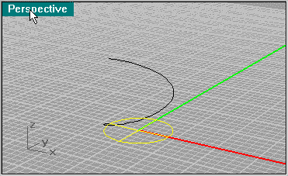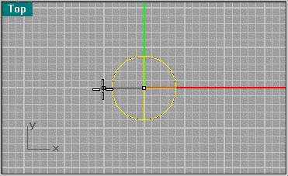
Now use Transform/Array/Along Curve to multiply the line segment 14 times. Make sure you have "Style" "Road like" selected.
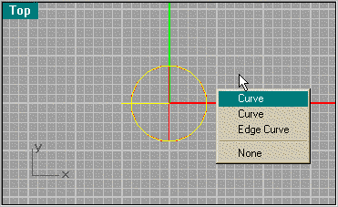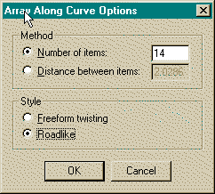
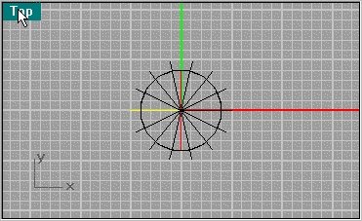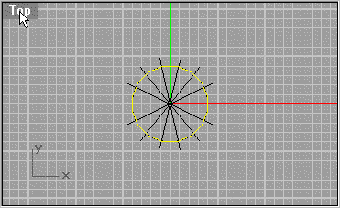
Now Split the surface with the lines selected. This will give you a pie segment that will be your step.
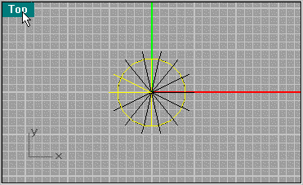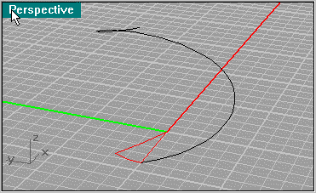
Now use Solid/Extrude Planar Curve at a thickness of .2 units to create a step, then delete the surface, or use Extrude on the edges, Join the pieces and then use Solid/Cap Planar Holes.
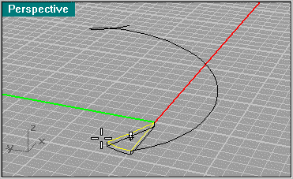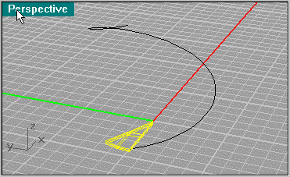
This Helix will be used allot. Now Array the step using Transform/Array/Along Curve, keep it to 14 pieces.
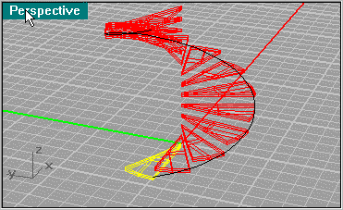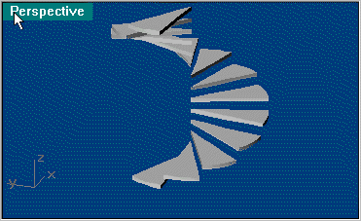
Now create a center shaft using Solid/Tube. Put a Sphere at the top to round it off. You can use the tube to cut the sphere in half, then join them. Next create a Rectangle at the base helix (.2 x 1.125 .175 from the top line). This will be the rail that holds the steps.
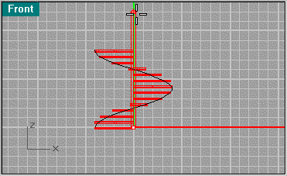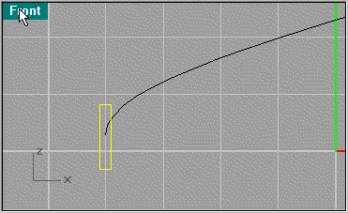
Now do another Transform/Array/Along Curve. A sweep is not possible in my experience because the rail will distort and be uneven, so creating an array will create a clean loft.
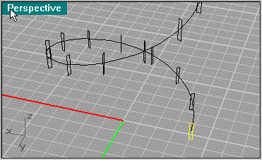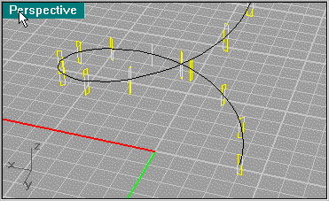
So highlight the segments and use Surface/Loft. When using loft, use Cap Planar Curves to cap the ends.
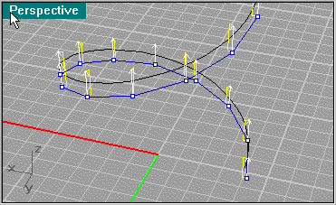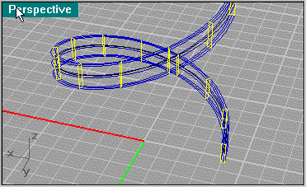
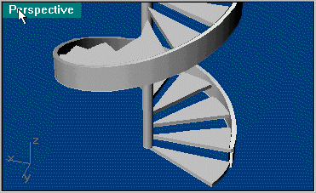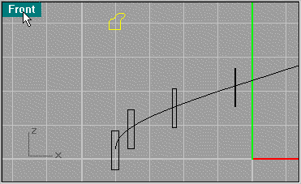
Next we create a banister. Their are many moldings of banisters, this one I made from a book. Use the Array again as you did for the lower rail.
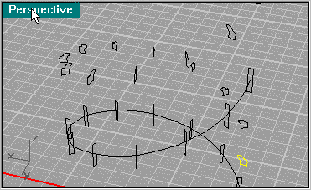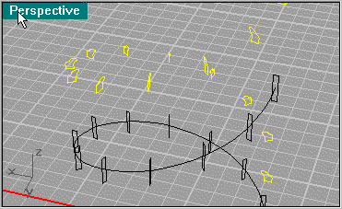
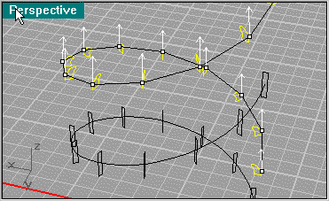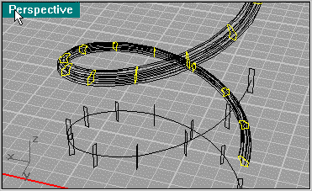
And here we have the simpler parts of the stairs. When you create Lofting, using custom points will determine how accurate the details are. Best is to experiment with 10, 20, 30 and "not simplified". Here I use Not simplified so the best detail can be shown. This will create a bigger file.
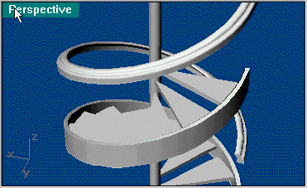
Here we will create the banister post. Click on the second picture to get a larger version. Here I did a line segment then revolved it and created the square base afterwards.
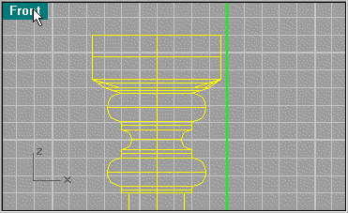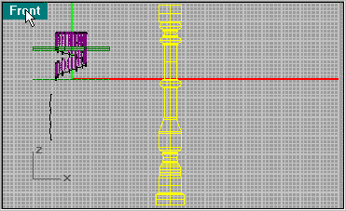
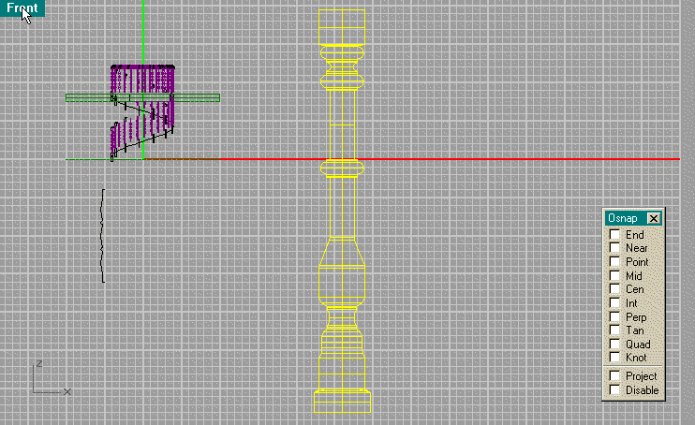
Looking at the top of the post create a Square to be use as a base by Extruding. Next line up the base as show.
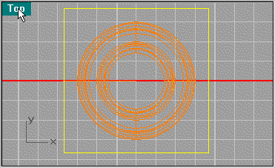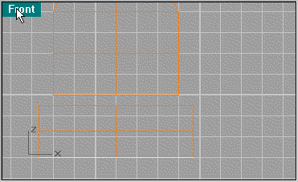
Create a line segment between the 2 objects using Snap Mid to line it up. Then use Sweep 2 Rails.
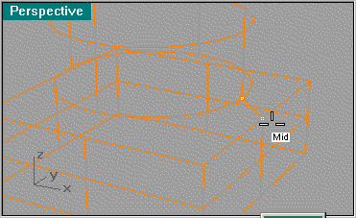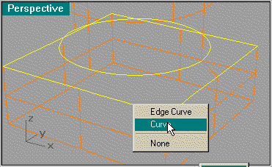
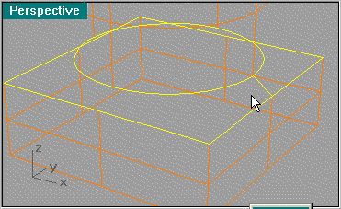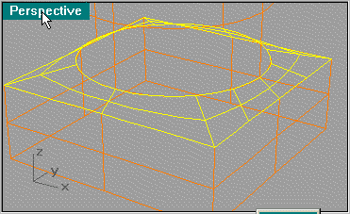
Next scale the post so it lines up from the floor to about were it is shown. What I did is put a cap on top and Fillet the edge.
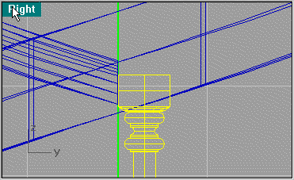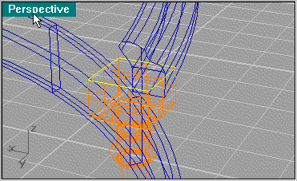
Use Extrude Planar Curve to create the cap and then use Solid/Fillet at .1 unit to bevel the edge.
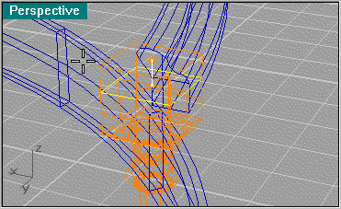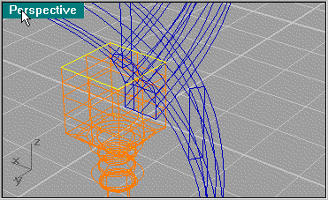
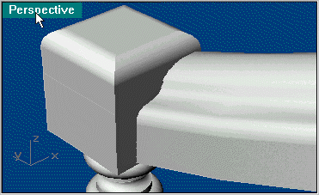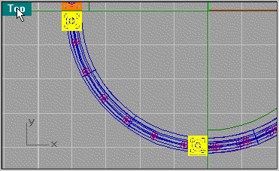
Next use Copy to create 2 posts at the end of the banisters on the second floor. The scale will be dealt with later.
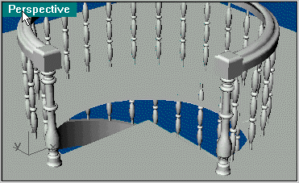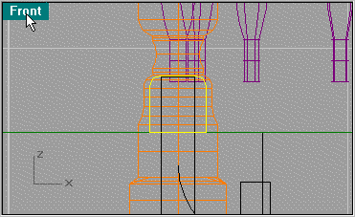
Next we will create a rail at the base of the spindles. I used a square then filleted the segment at .05 units and then scaled it down to this size.
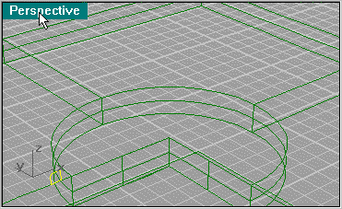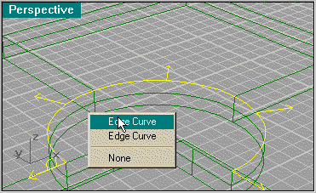
Use the Array to duplicate the pattern and then Loft.
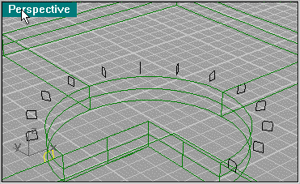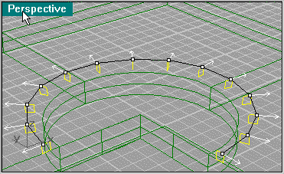
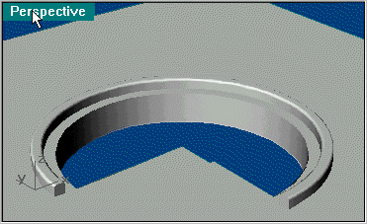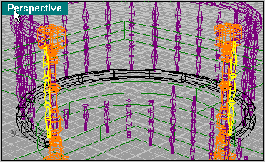
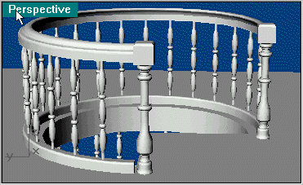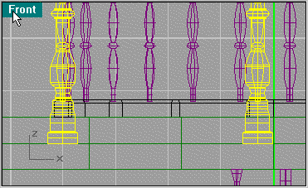
Now to scale the post, move the base block to line up with the floor. Then use Snap Center at the same time you use Scale 3D. select the top center of the post as shown then the bottom center. Move it up and align it with the center of the lower block.
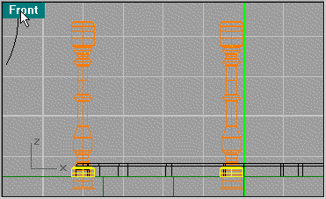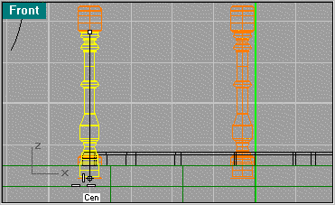
Now the pieces are proportionate.
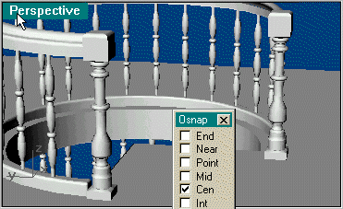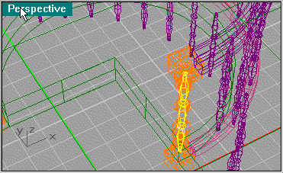
Next create an Array of spindles along the edge of the hole using 5 objects starting with the spindle that's in the banister post.
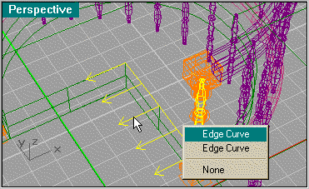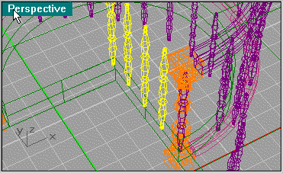
Next copy the floor base pattern as you made before and line it up as shown. Use Extrude Planar Curve to extrude it to the edge of the hole. Then Fillet the upper edges using .05.
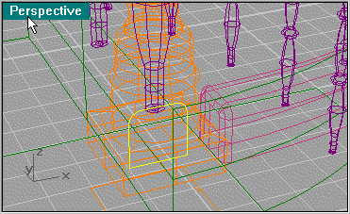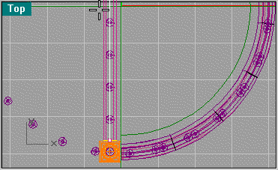
Next do the same with the banister pattern.
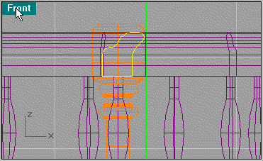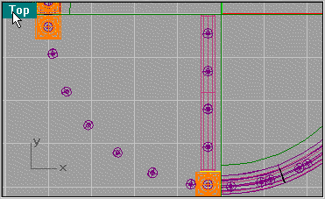
Here you see the final render. Click on second picture for larger picture.
