Modeling Web Camera
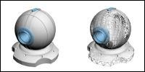 | Another great modeling tutorial by Smasher. Its been only couple of days, and here is another. Here you will learn how to model Web Camera !!!

STEP ONE
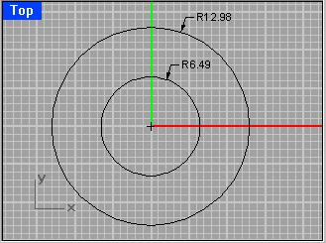
Lets go to TOP VIEW and create two circles. You can see the radius I used. Make the center in 0,0 coordinates like on the picture. You need to Copy and Paste (CTRL+C, CTRL+V) the bigger circle. You can hide it.
STEP TWO
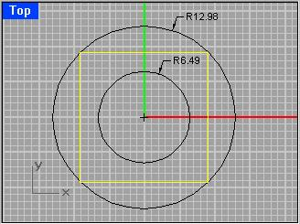
Now, make a rectangle so it fits bigger circle, like on the picture.
STEP THREE
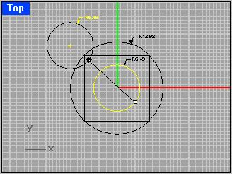
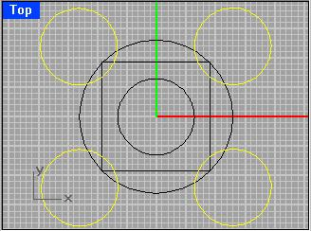
Select smaller circle and Copy & Paste (CTRL+C, CTRL+V) it, and then move it (Command: MOVE) like on picture1, in the first angle of rectangle. Now, you can Mirror (Command: MIRROR) or just Copy & Paste (CTRL+C, CTRL+V), just make the circles like yellow ones on the picture2.
STEP FOUR
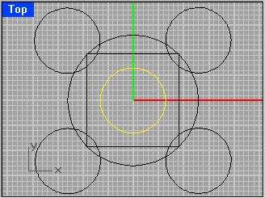
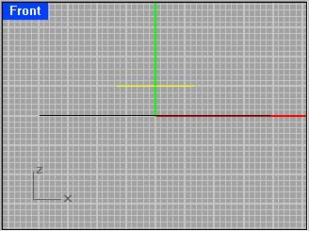
Select the circle in the middle, like on the picture, and then, go to FRONT VIEW and move it (Command: MOVE) like on the picture2.
STEP FIVE
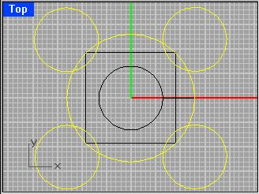
Using Split (Command: SPLIT) you must split big circle with 4 small, and split 4 small with one big. First, lets split the big one. Select the big one, and type Split, after that select those four smaller circles and press ENTER, or click RIGHT MOUSE BUTTON.
STEP SIX
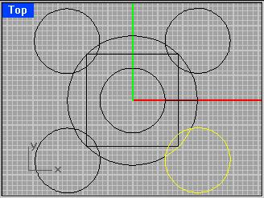
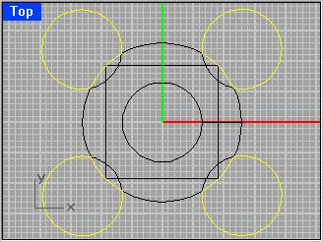
Here, we will split 4 small ones with the big one. Select one small circle, and type Split. Then select that piece of curve that is inside of that small circle, like on the picture1. Do it for all four small circles. Now you can select those things you don't need and Delete. Like on the picture2.
STEP SEVEN
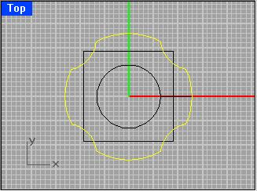
Now, select this "flower" and Join it (Command: JOIN).
STEP EIGHT
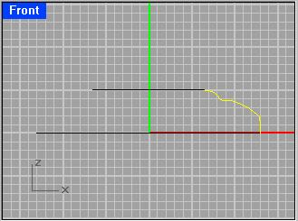
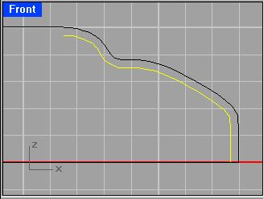
Ok, now you have to make a curve like on the picture1. Go to FRONT VIEW. Go on, do it. You will have to offset it (Command: OFFSET) by 0.3. So type in Offset and don't click nothing unless you typed in 0.3. Now, offset it inside like on picture2.
STEP NINE
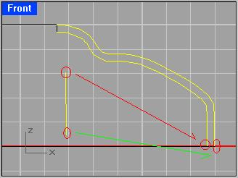
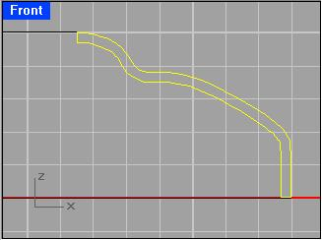
We will be using command MATCH now. Create two lines (NOT CURVES) anywhere. Now type in MATCH and select any end of one line and then select one end of one curve, and then type Match again and then select another end of LINE and then select end of another curve. Repeat the process for other Line. What you have to get is on picture2, now you can Join (Command: JOIN).
STEP TEN
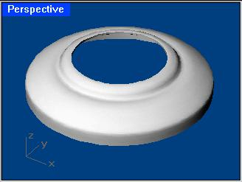
Now we will revolve something here. Type in Sweep2 and select those first two circles you created in STEP ONE. After that, select that joined curve you created in previous step. Press ENTER. You must get something like on the picture.
STEP ELEVEN
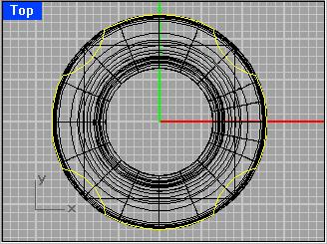
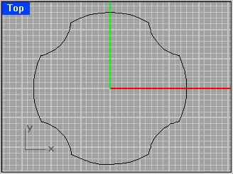
Select that "flower" you made in STEP SEVEN.
STEP TWELVE
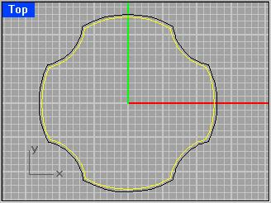
Go to TOP VIEW. Now type in OFFSET and type in 0.4. Offset it inside, like on the picture. Keep it selected.
STEP THIRTEEN
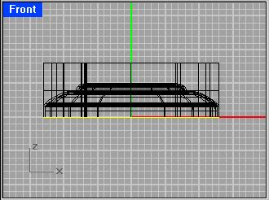
Now that you have it selected, Go to FRONT VIEW and type in EXTRUDE and extrude it so it is taller than that surface you already have, like on the picture.
STEP FOURTEEN
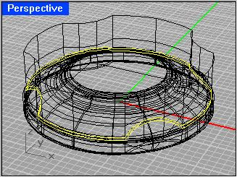
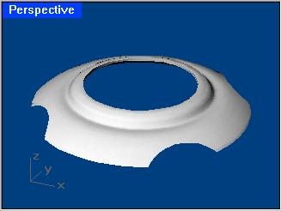
Now select extruded surface and that circular surface and type in INTERSECT. Now select that circular surface and type in SPLIT and select that flowerlike surface (Extruded one). Remove all unwanted surfaces. So you get smth likw on the picture2.
STEP FIFTEEN
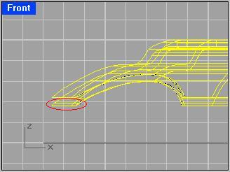
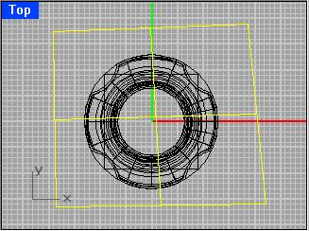
Now you see, we have one problem we are about to get rid of. In th picture1 you can clearly see what that is. Now go to TOP VIEW, and create a surface out of 3,4 corner points. Type in SRFPT. Make a surface like on picture2.
STEP SIXTEEN
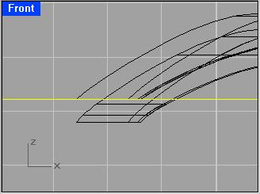
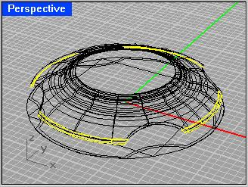
Go to FRONT VIEW and move that surface out of 3,4 corner points like on the picture1. Now we will split the part we don't need. Select that surface and type in SPLIT. Select the surface out of 3,4 CP. Press ENTER. (Or DON'T). Remove unwanted parts like selected on the picture2.
STEP SEVENTEEN
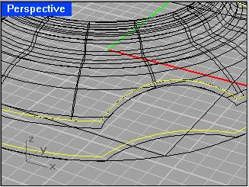
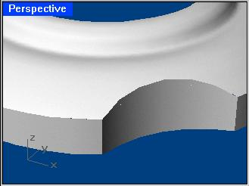
Select the curve that is on the outer edge of this surface and select inner flowerlike curve (the one you offseted in STEP TWELVE) and type in LOFT. That should do it, so you have something like on the picture2. SHADE it to see it better.
STEP EIGHTEEN
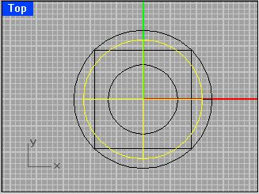
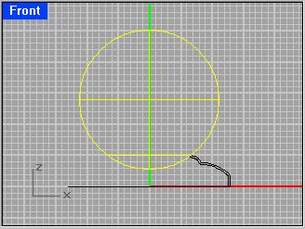
Hide the surfaces and leave those two circles you created in STEP ONE. Go to TOP VIEW and type in SPHERE. Then type in the center of sphere 0,0 and then type the radius 10. Go to FRONT VIEW and move the sphere so it sets just fine in that smaller circle like on the picture2.
STEP NINETEEN
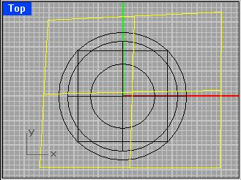
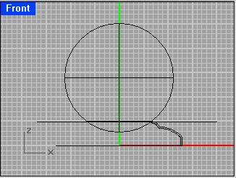
Go to TOP VIEW and create surface out of 3,4 CP like you did in STEP FIFTEEN. Now go to FRONT VIEW and select that surface, move it up a bit to the smaller upper circle, like on the picture2. Now select the sphere and Copy & Paste it (CTRL+C,CTRL+V) and you can hide one of those two. Select one again and type in SPLIT and select that surface. You can delete upper part of sphere.
STEP TWENTY
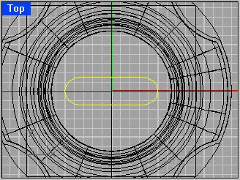
Go to TOP VIEW and created rounded rectangle. If you don't know how to make a rounded rectangle, follow this. Type in RECTANGLE, and before anything type in R. Now select the measures of it and then select radius for selected rectangle. Just make it like its on the picture.
STEP TWENTY ONE
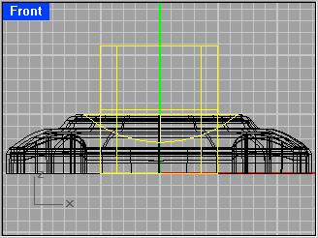
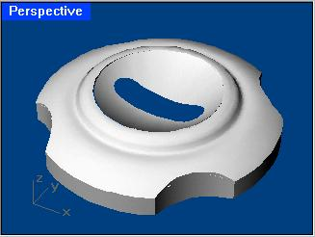
Go to FRONT VIEW and select that rounded rectangle you just created and type in EXTRUDE. Extrude it like on the picture. Now select that chopped sphere you splited in STEP NINETEEN and type in INTERSECT. Now, first select that chopped sphere and type in SPLIT, and then select that extruded surface and press ENTER. You can delete extruded surface. You must get smth like on the picture2.
STEP TWENTY TWO
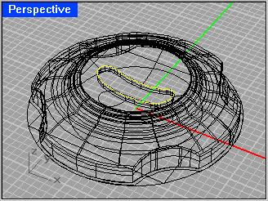
Select the curve you intersected with deleted extruded surface and chopped sphere (image1) and type in EXTRUDE, extrude it down.
STEP TWENTY THREE
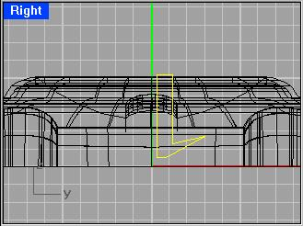
Go to RIGHT VIEW and type in POLYLINE. Make a line like on the picture... a bit right from the green line. Now type REVOLVE. Now you have to start revolve axis. Just type in 0,0. And then type in the end 0,5. A window pops up, make sure that your start angle is 0 and end angle is 380. Click OK.
STEP TWENTY FOUR
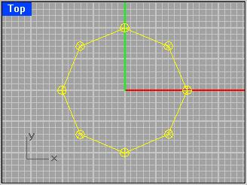
Go to TOP VIEW and HIDE everything except that rectangle. We will make a polygon with 8 corners. So type in POLYGON, and before anything type in N and then type in 8. That will make it have 8 corners. For the center type in 0,0 and for the corner of polygon type in 10 and for corner of polygon type in 0,5. Now type in SPHERE and for the center of sphere click on one of the corner of polygon, nevermind which and then type in the radius 0.7. You can Copy&Paste other spheres and MOVE them like on the picture. Type in SHOW to unhide all.
STEP TWENTY FIVE
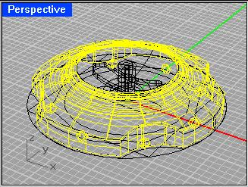
Select those eight spheres you created in previous step, and that main polysurface. Type in INVERT and then type in HIDE.
STEP TWENTY SIX
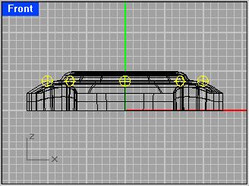
Go to FRONT VIEW and select only 8 spheres. Type in MOVE and for Point to move from type in 0,0 and for Point to move to type 0,3.8.
STEP TWENTY SEVEN
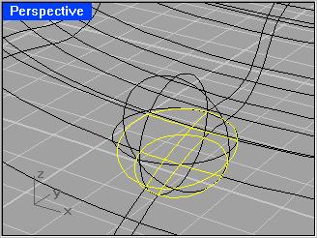
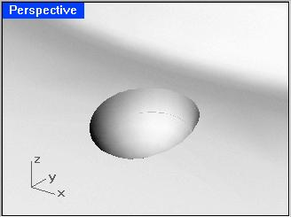
Now we will use a little SPLIT command. Select main surface (bottom of camera) and type in SPLIT. Now select sphere. Nevermind which, you will repeat this step for all 8 spheres. Now select sphere, and type SPLIT and select main surface and press ENTER. Now you must delete all unwenated surfaces. That is top of the sphere and those circle surfaces. so you get smth like on the picture2.
STEP TWENTY EIGHT
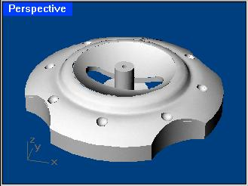
So you created this. Now its time to create that eye on top. :)You already have hidden sphere you will need to show now.
STEP TWENTY NINE
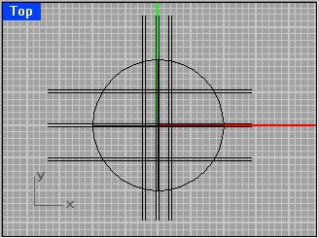
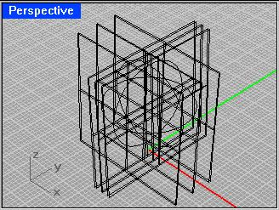
Select only sphere and everything else HIDE. Go to TOP VIEW. Now, from RIGHT and FRONT VIEW make surfaces out of 3,4 corner points and place them like one the images. It would really take too many steps to make this easy part, so I made it this simple. You'll have to make this one yourself. Just watch the pictures, and there shouldn't be ANY problems. After you created all the surfaces needed, select the sphere, and vertical surfaces (from top view) and type in INTERSECT, after that select sphere again and horizontal surfaces (from top view) and type in INTERSECT. Now you should get 12 circles on the sphere.
STEP THIRTY (30)
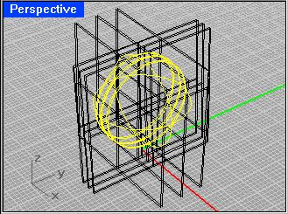
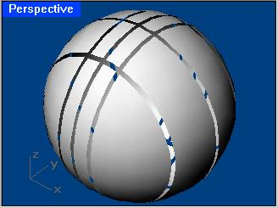
Select sphere, and then type in SPLIT and select horizontal set of surfaces (from top view) and press ENTER. Now its important not to click anywhere. You have selected surfaces like on the picture1. Just type again SPLIT and select vertical set of surfaces (from top view) and press ENTER. Now it is time to delete all unwanted surfaces.. Those you splitted like showed on the picture2.
STEP THIRTY ONE
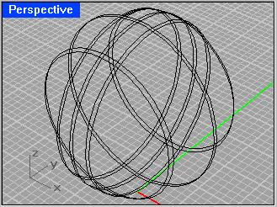
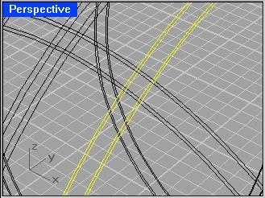
This image is quite a same one like that blue backgrounded in previous step, but these are circles not split sphere. So when you hide sphere and show circles, it is time we make offsets of each circle inside!!This is very important. INSIDE! 12 circles and 12 offsets. The same procedure as for only one. :) Select one circle and type in OFFSET, type in 0.1 and then press ENTER. Do it for all of them, and you should have something like image2.
STEP THIRTY TWO
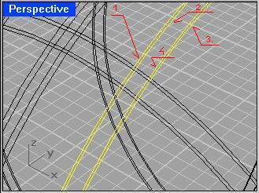
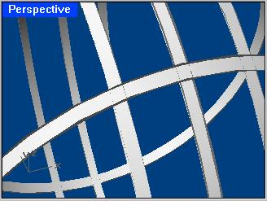
Now it is time we make lofted holes. So follow the numbers on image1. This is the order you have to select circles. So type in LOFT, and select circles in showed order. Click RIGHT MOUSE BUTTON. A window pops up. Set Style to Straight sections. Do this for every set of 4 circles. Then, you will get 6 surfaces like showed on picture2. Type SHOW, to show those pieces of sphere. Sellect all and join. SELALL, JOIN.
STEP THIRTY THREE
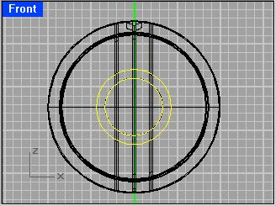
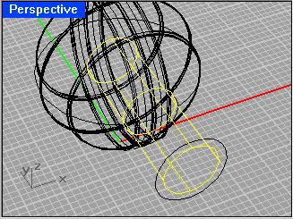
Go to FRONT VIEW, make two cirlces like this on the picture1. Select smaller one and EXTRUDE it to the half of sphere, like on picture2.Select all the surfaces of sphere and those three stripes and split them with this extruded circle. Just type in SPLIT.
STEP THIRTY FOUR
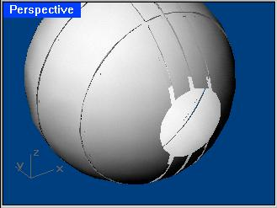
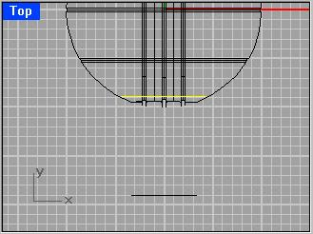
Now that you split those surfaces, you need to get something like this on the picture1. Now, remember you created two cirlces in previous step??? Oh, yes you did. Select bigger one and move it like on the picture2.
STEP THIRTY FIVE
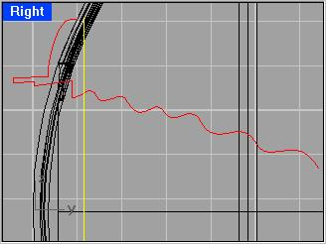
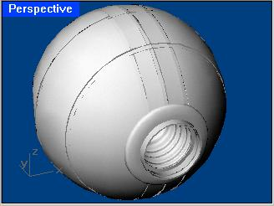
Go to RIGHT VIEW and create a line using CURVES AND LINES (Commands: INTERPCRV, POLYLINE) and after that you just match and join them. (Commands: MATCH, JOIN). This yellow line acctually is not line, it is that bigger circle you moved in previous step. Type in SWEEP1 and select that yellow circle, after that select red line and press ENTER. Click OK. You got something like picture2.
STEP THIRTY SIX
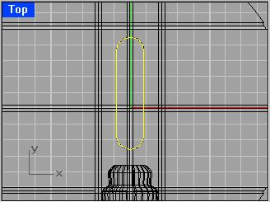
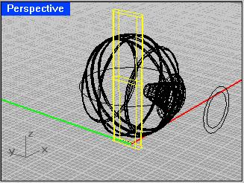
Go to TOP VIEW and repeat STEP TWENTY and make a rounded rectangle like on the picture1. Extrude that rectangle like on the picture2. Do NOT delete that extruded rectangle, use it to split surfaces that intersect with it. You'll have to split one stripe and 4 surfaces. Intersect it with 4 surfaces.
STEP THIRTY SEVEN
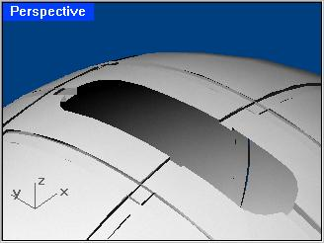
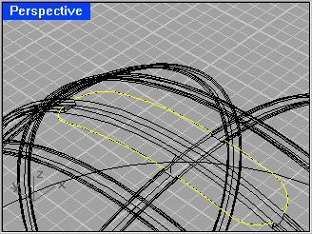
If you INTERSECTED extruded rectangle and 4 surfaces then you should get curves like on the picture2.
STEP THIRTY EIGHT
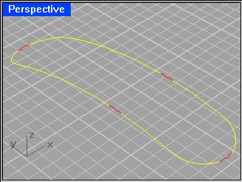
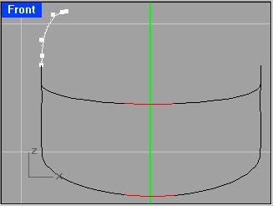
Use BLEND command to fill the gaps between curves. Red curves are blended curves(red ones) between two near curves(yellow ones) JOIN them. Now, go to FRONT VIEW and make a curve like in the picture2. White curve.
STEP THIRTY NINE
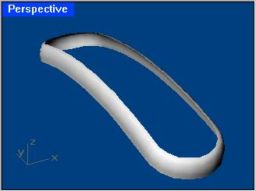
Select that rounded rectangle you just joined in previous step and type SWEEP1 and select curve you created in previous step also(white on the picture) and press ENTER. You should get something like this on the picture. If not, keep trying.
STEP FOURTY
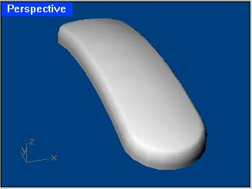
Type in PATCH and select upper edge of that surface you created using SWEEP1 and press ENTER, window pops up. Check Adjust Tangency. Press OK.
STEP FOURTY ONE
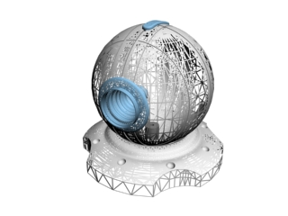
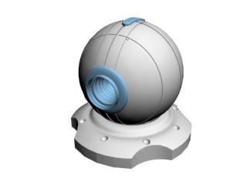
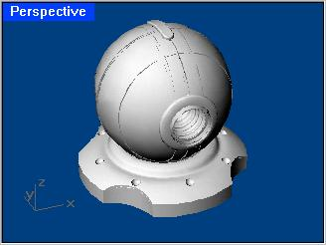
Thats it !!! You Can unhide all objects using SHOW command, and select all of it using SELALL and join everything using JOIN. THE END.

